[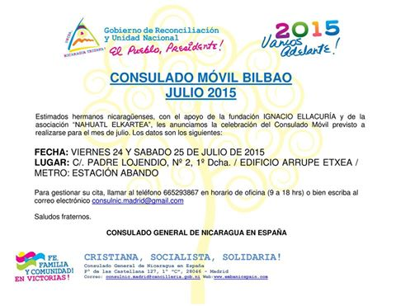](https://es-es.facebook.com/255310661260303/photos/a.262210003903702.1073741834.255310661260303/412501028874598/?type=1)